**ADULT FOLLOW UP**

Patient’s Name: ____________________________________ Date of Birth: ________________

Today’s Date: _______________ Date of Procedure:_____________ Days Since Procedure : _______

**INSTRUCTIONS**: Please mark any previous issues that saw improvement. Anything that worsened, please write below.

**Speech**

___ Others understand speech better

___ Less embarrassed with communication

___ Less shy in social situations

___ Easier to speak fast or long sentences

___ Easier to get certain words out

___ Easier with sounds (which?)__________________

___ Get less tired when talking or reading aloud

___ Less stuttering

___ Less mumbling or speaking softly

___ Can talk or sing louder now

Anything worsened?:

**Feeding**

___ Less frustration when eating

___ Easier to eat and swallow solid foods

___ Eating faster

___ Eating more food / better appetite

___ Finishing meals better/ less grazing on foods

___ Easier to swallow pills

___ Easier to clean teeth off with tongue

___ Less picky with textures (which?)________________

___ Less choking or gagging on food or liquids

___ Other:

Anything worsened?:

**Sleep issues**

___ Less sleeping in strange positions

___ Less moving around at night (less restless)

___ Sleeping deeper and waking less often

___ Less need of a sleep appliance at night

___ Wake up less tired and more refreshed

___ Less grinding teeth while sleeping

___ Less sleeping with mouth open

___ Less snoring while sleeping

___ Less gasping for air or stopping breathing

Anything worsened?:

**Other related issues**

___ Less neck or shoulder pain or tension

___ Less TMJ pain, clicking, or popping

___ Less headaches or migraines

___ Less mouth open/mouth breathing during the day

___ Less reflux or ___ Less constipation

___ Can focus and pay attention better (less brain fog)

___ Less stress / anxiety

___ Easier to breathe through nose

___ Better kissing / intimacy

___ Easier to brush top teeth (after lip-tie release)

___ More cosmetic smile (after lip-tie release)

**How much change did you see from the release? (circle one):**

**Speech**

Significantly better / Somewhat better / No Change / Somewhat worse / Significantly worse // No prior issues

**Feeding**

Significantly better / Somewhat better / No Change / Somewhat worse / Significantly worse // No prior issues

**Sleep**

Significantly better / Somewhat better / No Change / Somewhat worse / Significantly worse // No prior issues

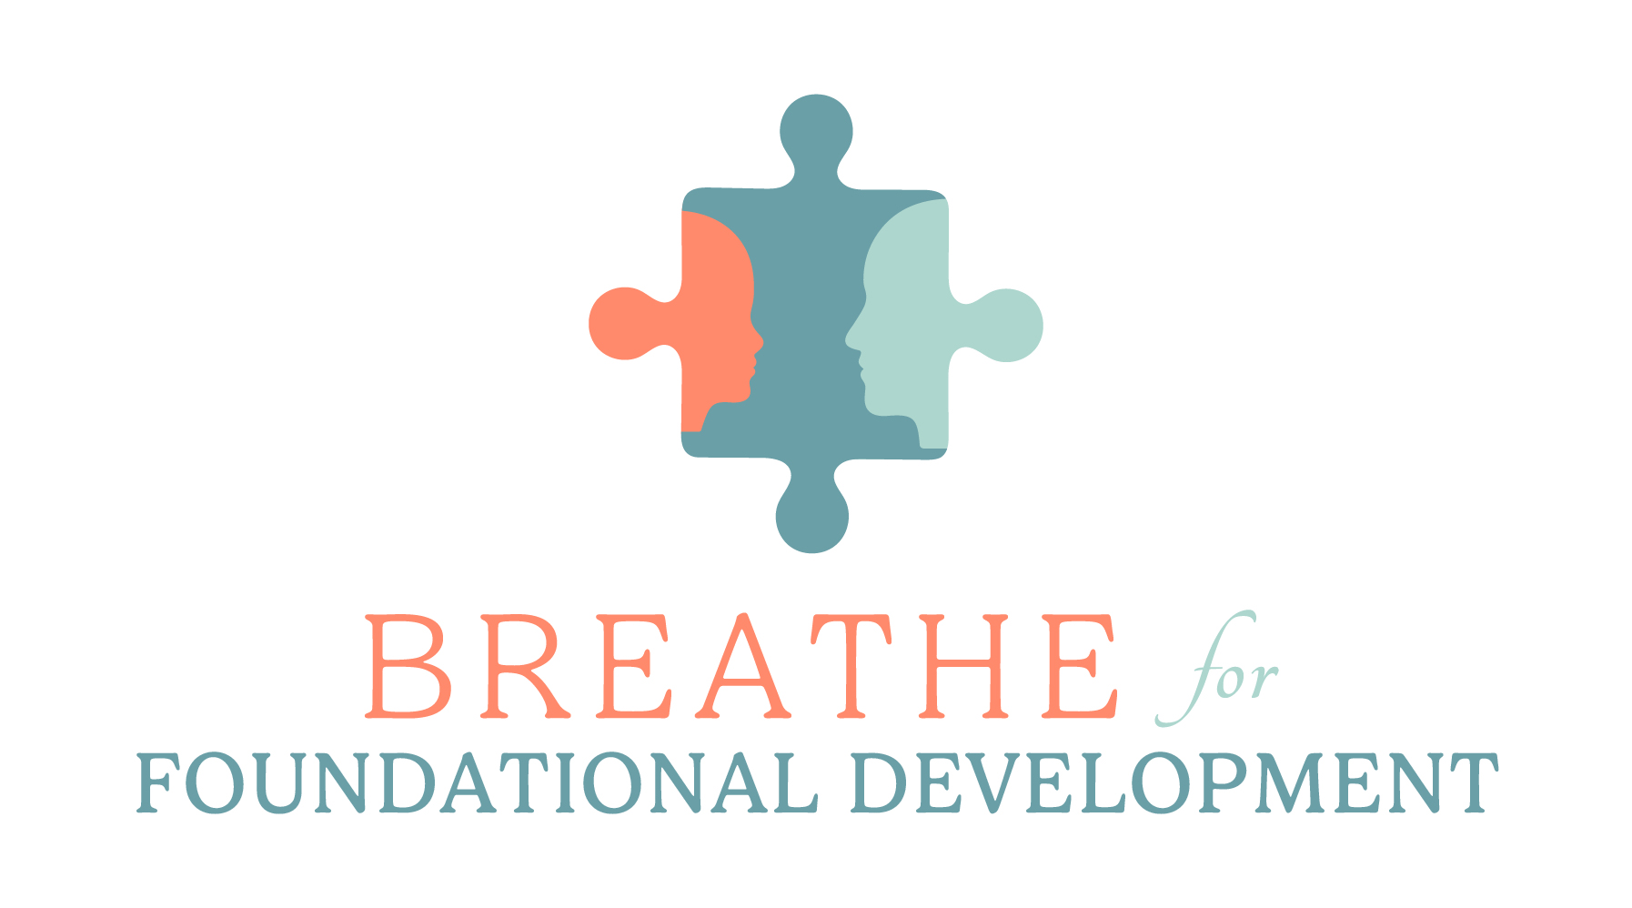**Looking back, if you “had to do it all over again,” would you?**

Yes / Maybe (probably yes) / Unsure / Don’t think so / Never